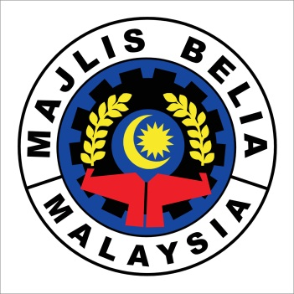
MALAYSIAN YOUTH COUNCIL
INTERNATIONAL YOUTH PROGRAMME

Please ( / ) your preferences in the remark box.
NO | PROGRAMME | REMARK
1 | WorldSkills Abu Dhabi 2017

- PERSONAL DETAILS
NAME
GENDER |  | NATIONALITY
I/C NUMBER |  | RACE
DATE OF BIRTH |  | RELIGION
PLACE OF BIRTH |  | AGE
HOME ADDRESS |  | MOBILE NUMBER
 |  | HOME NUMBER
EMAIL

- OCCUPATION DETAILS (for those who are working)
EMPLOYER
OFFICE ADDRESS |  | OFFICE NUMBER
 |  | FAX NUMBER
POSITION

- EDUCATION DETAILS
UNIVERSITY/COLLEGE/
POLYTECHNIC
ADDRESS |  | OFFICE NUMBER
 |  | FAX NUMBER
COURSE /MAJOR
LATEST PNGK

- ORGANISATION DETAILS
YOUTH ORGANISATION

OFFICE ADDRESS |  | OFFICE NUMBER
 |  | FAX NUMBER
POSITION
YOUTH ORGANISATION’S ENDORSEMENT
This applicant is a member of this organization since (year):
Official
Stamp

____________________
Name :
President/Secretary :

- EMERGENCY NUMBER
NAME
RELATIONSHIP |  | CONTACT NUMBER

F) EXPERIENCE IN VOLUNTEERING. Please detail any experiences you have in volunteering.
G) AREA OF INTEREST. Choose one
( ) Special Event Volunteers
( ) VIP, Media & Communication
( ) Volunteer Coordination & Operational Support

**Please return your complete application form and resume to Malaysian Youth Council by 12th April 2017 to email mbm@belia.org.my. Applications submitted after this time may not be considered**

